**HANDOUT 1 FOR TUTORIAL ONE**

1. **Choose the correct article: a, an, the or x (no article)**
2. Are you coming to       party next Saturday?



1. I bought       new TV set yesterday.



1. I think       man over there is very ill. He can't stand on his feet.



1. I watched       video you had sent me.



1. She was wearing       ugly dress when she met him.



1. I am crazy about reading       history books.



1. She is       nice girl.



1. Do you want to go to       restaurant where we first met?



1. He is       engineer.



1. He thinks that       love is what will save us all.



Source: <https://www.myenglishpages.com/site_php_files/grammar-exercise-articles-2.php>

1. **Underline all the articles in the passage below. Let’s see how many you can find. (Optional)**

Online learning is education that takes place over the Internet. It is often referred to as “eLearning” among other terms. However, online learning is just one type of “distance learning” – the umbrella term for any learning that takes place across distance and not in a traditional classroom. Distance learning has a long history and there are several types available today,

By far the most popular approach today is online learning. According to the Sloan Consortium, online enrollments continue to grow at rates faster than for the broader student population and institutes of higher education expect the rate of growth to continue increasing.

In years past, instructors had to create their “virtual classrooms” from scratch which was difficult and often led to poor results. Today, an entire industry has emerged to do this for us. Course Management System (CMS) software is utilized by just about all colleges today. CMS allow instructors to design and deliver their courses within a flexible framework that includes a number of different tools to enable learning and communication to occur.

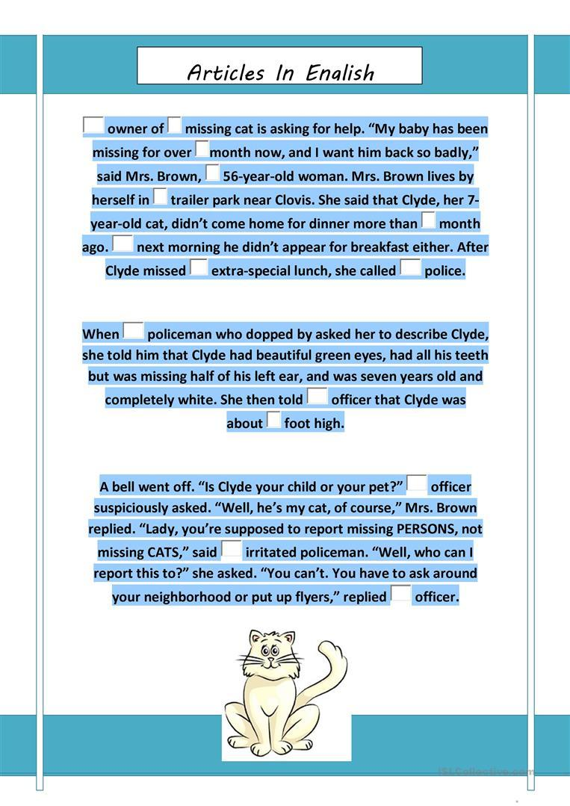

**ACADEMIC WRITING**

**ACTIVITY TWO**

1. List 03 important qualities of Academic English.

……………………………………………….

…………………………………………………

…………………………………………………….

2. In referencing what is the most important thing you have to do?

……………… ………………………………………..

3. Mention 3 common errors you should not do when using Academic English.

………………………………………………………………………………………………

………………………………………………………………………………………………

………………………………………………………………………………………………

……………………………….…………………………………………………..…………

Answers

* 1. Watch the video and answer these questions in brief

List 03 important qualities of Academic English.

………Impersonal Style (Not writing opinions such as I think, as we all think etc)

……Formal and neutral (No contractions – It doesn’t= It does not/ It can’t= It cannot etc It hasn’t been received = I has not been …../ NO slang/ no phrasal verbs/ no casual expressions )

Use of linking words/logical connectors to create organization and order

……

* 1. In referencing what is the most important thing you have to do?

……………… you need to cite the sources using any style of referencing such as APA/ HARVARD etc

* 1. Mention 3 common errors you should not do when using Academic English.

No contractions

No personal pronouns (Such as I/ we/you- use the 3rd person or the passive voice)

No opinions/ casual expressions